**Assignment-1**

1) checking version of git

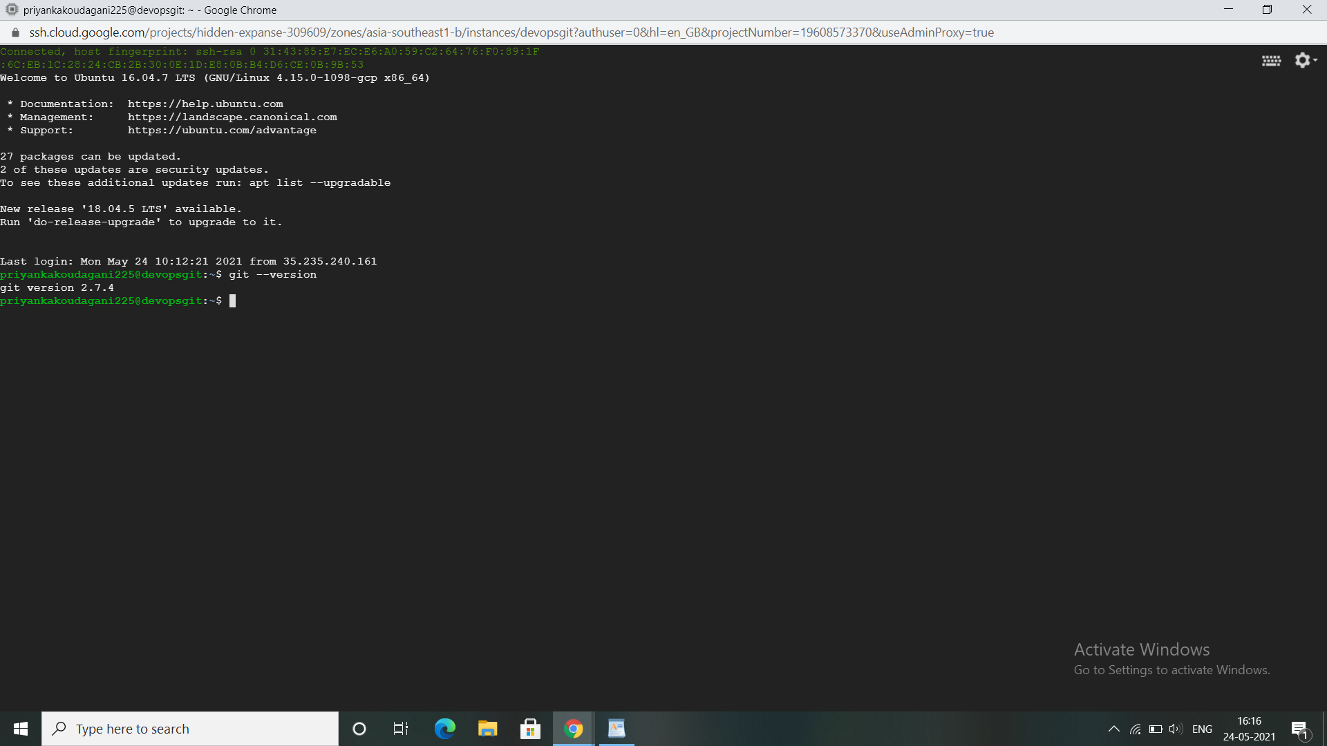

2) creating developerA directory and git init

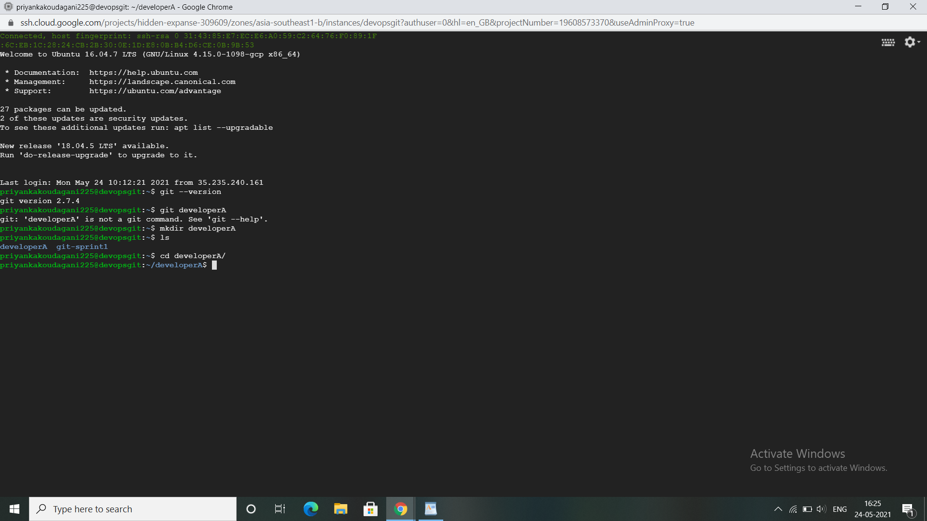

3)git init-local repo

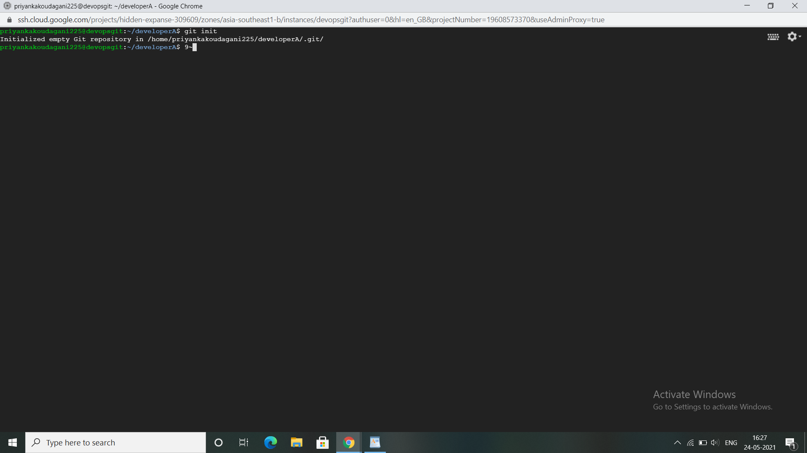

s

4)adding files

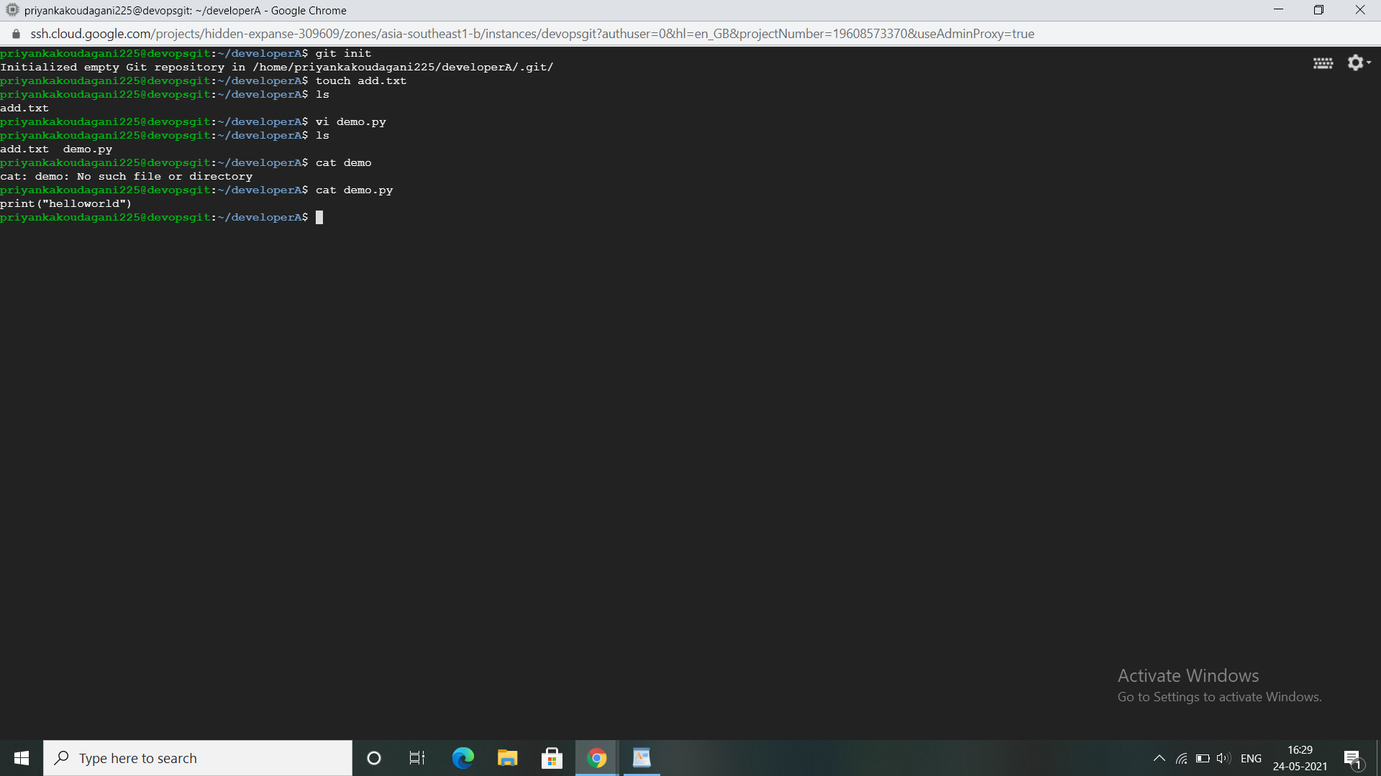

5)Added the files to staging area with git add .

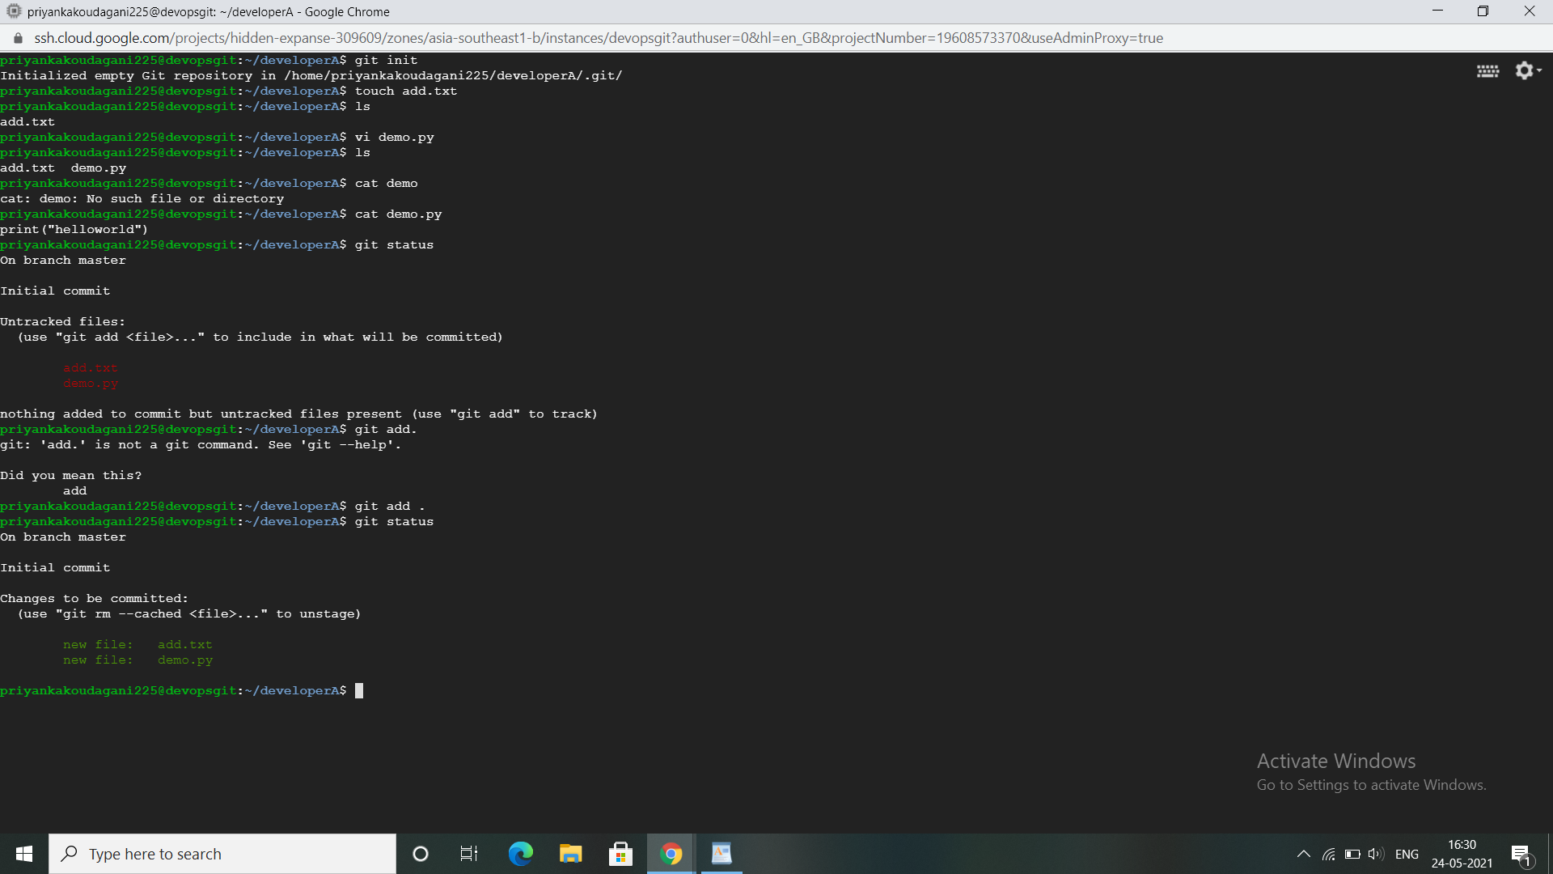

6)Committed with below comments

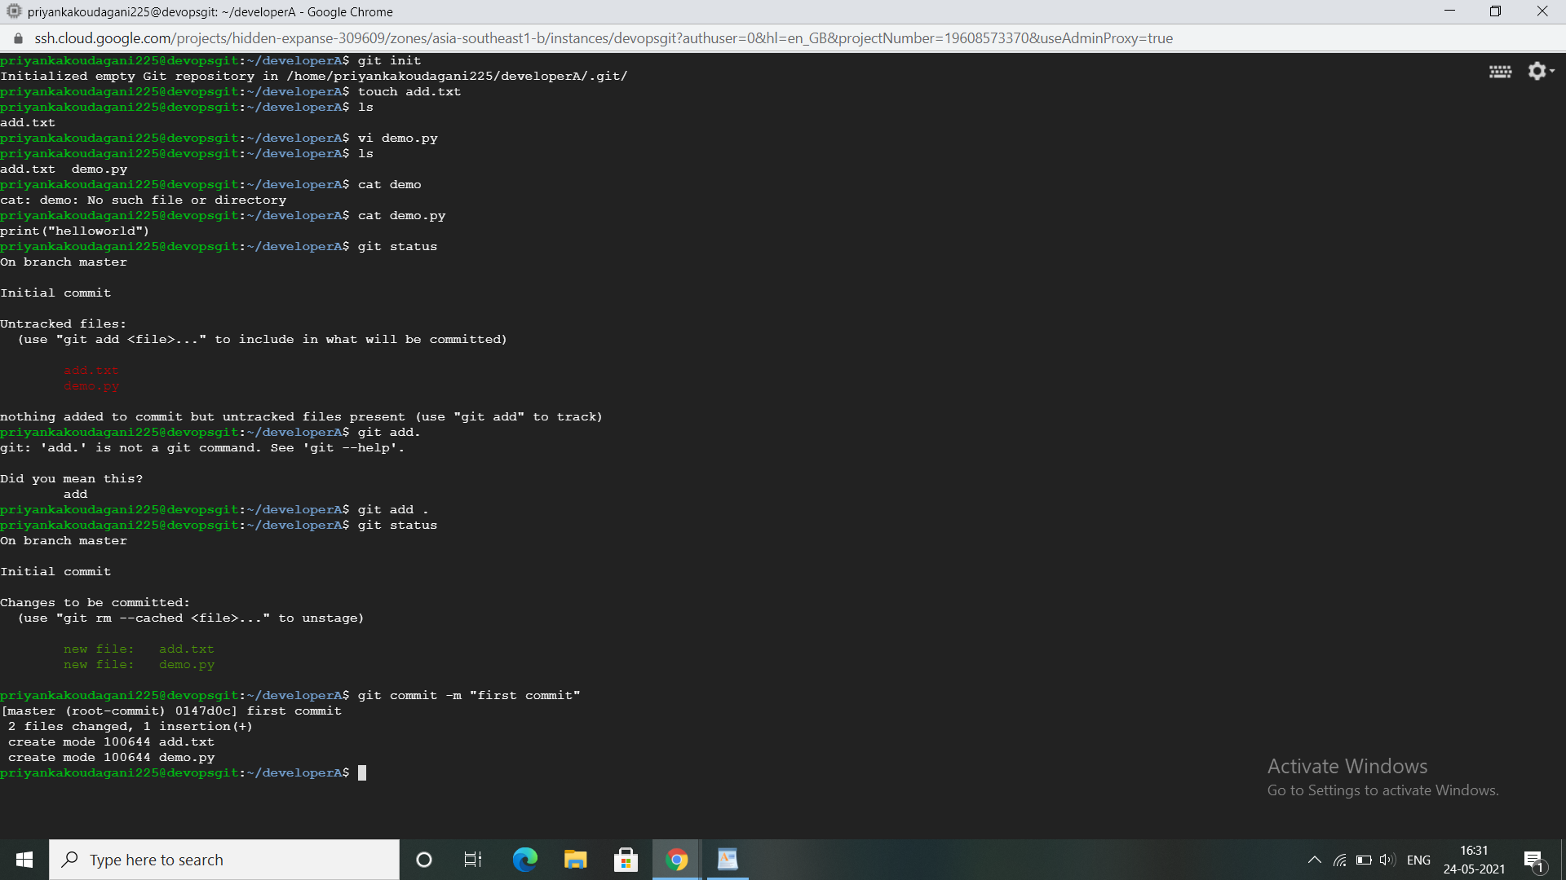

7)I have added remote repository to local repository with git remote add origin

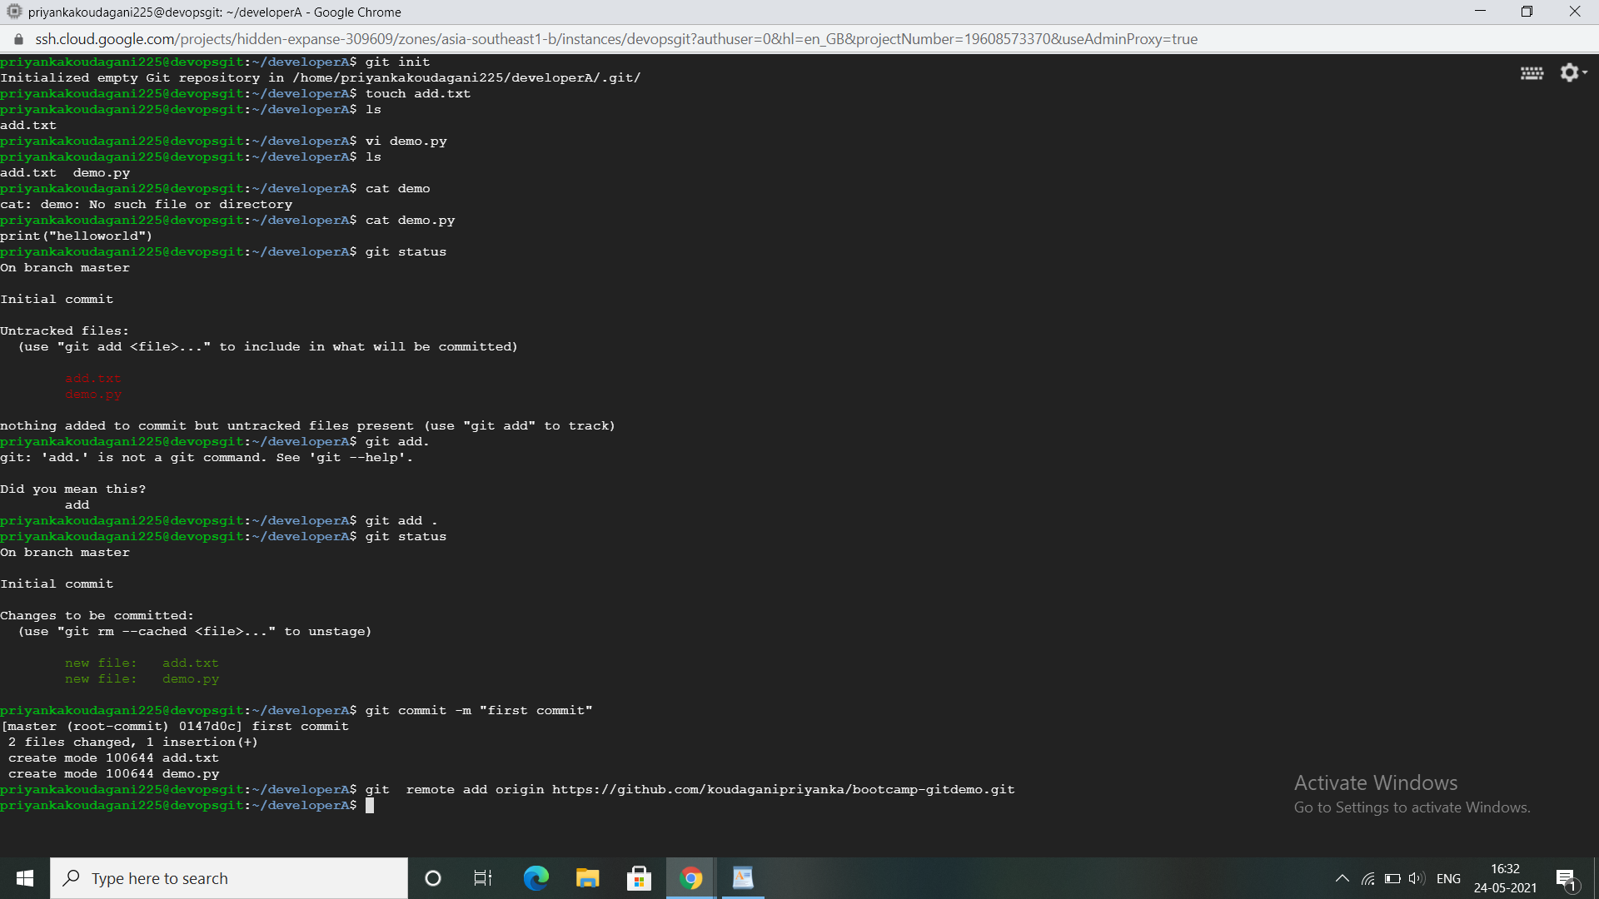

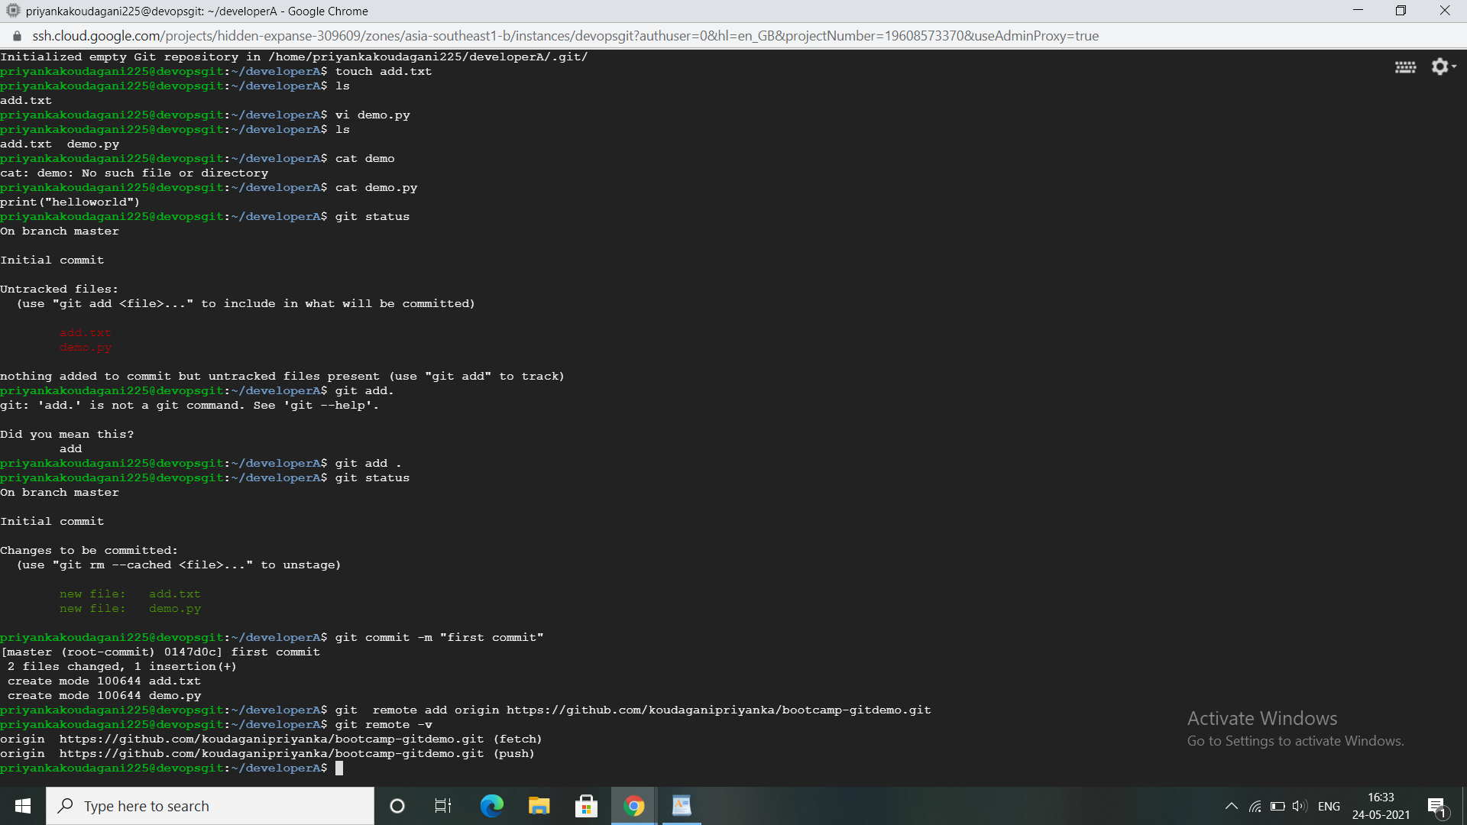

8)Pushed the content to remote repository with git push

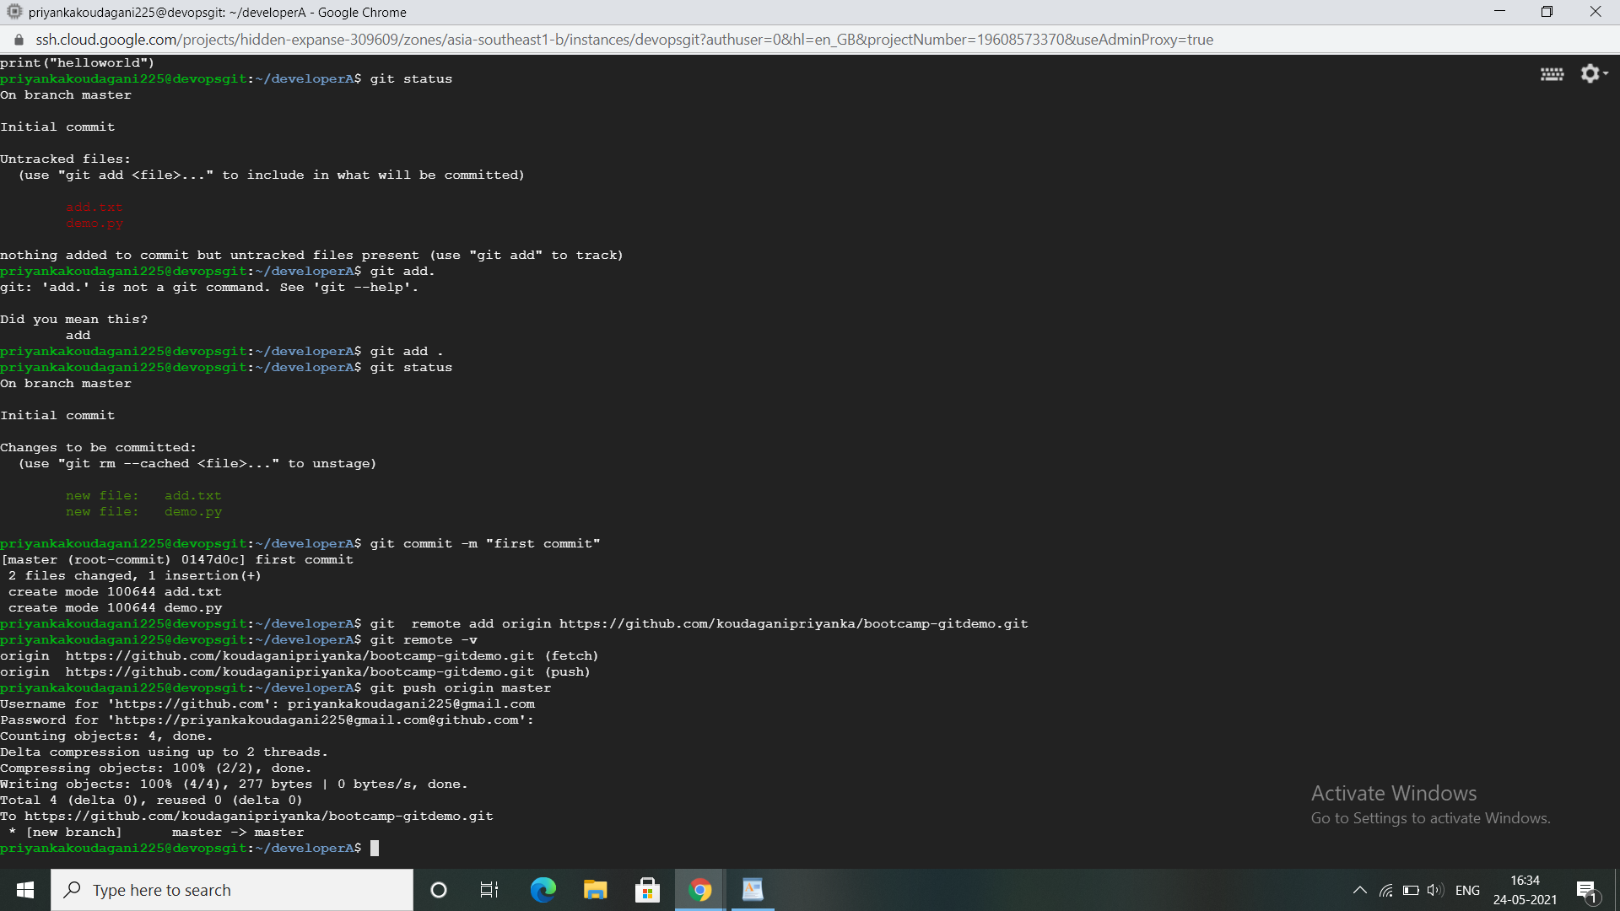

9) I have copied the remote repository URL and used got clone using **below command** to clone to the local into DeveloperB

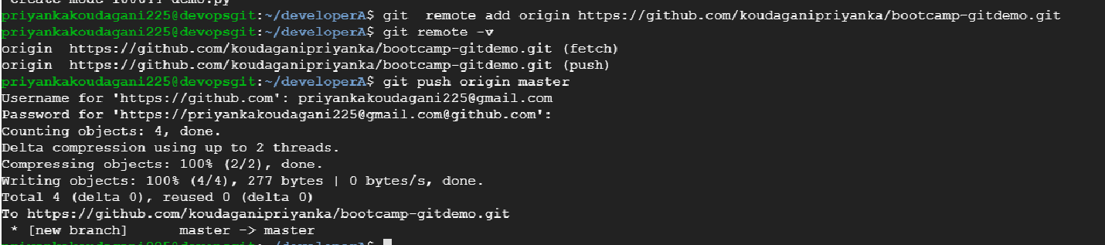

10)I have added an extra lines in file

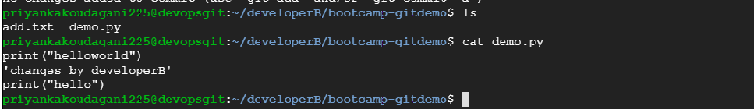

11)I have committed the changes with below message

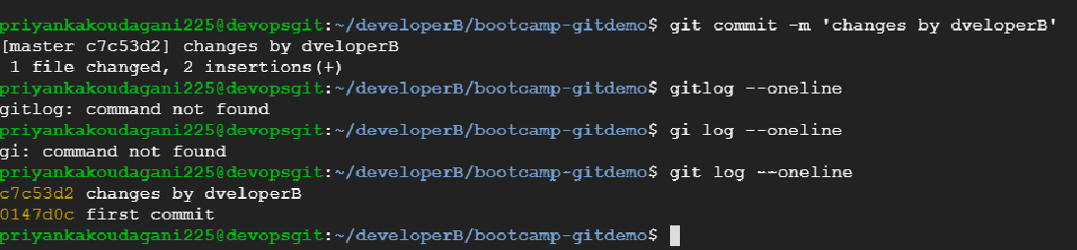

12)After committing, I have pushed the code to remote

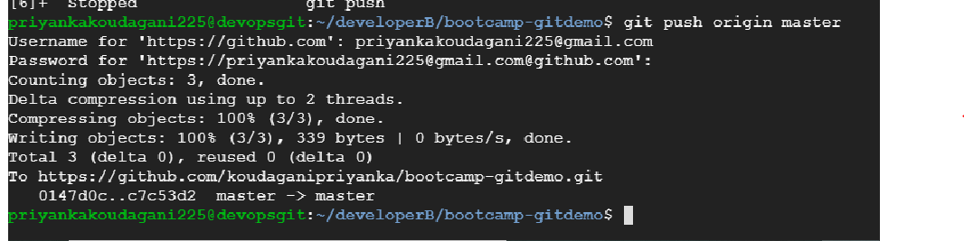

13)In DeveloperA, I have pulled these changes which i have done in developerB with below command

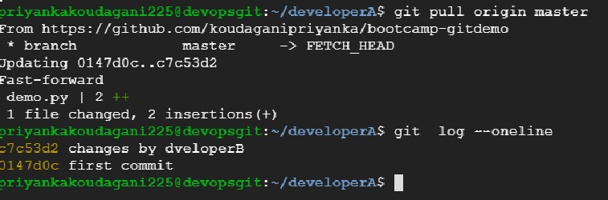

14) I have created a new branch called feature1 with the below screen command and switched to branch to taht branch

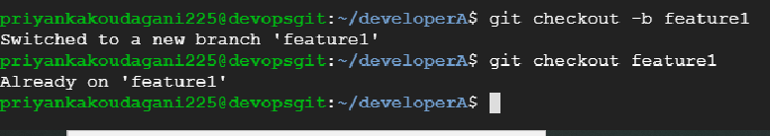

15)I have done changes in file and I have added to staging and committed

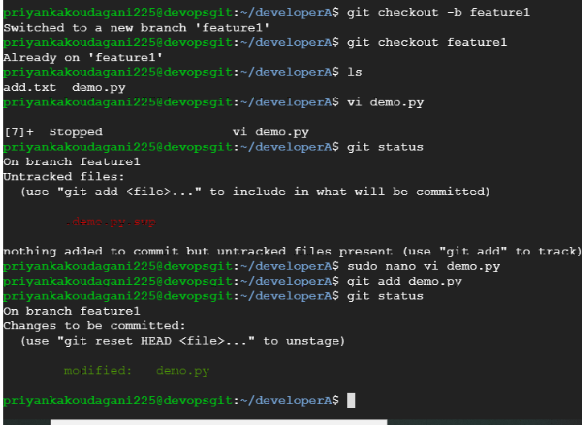

16)After committed the code, I have switched to master branch with git checkout master and merge the branch with master with the command git merge feature1

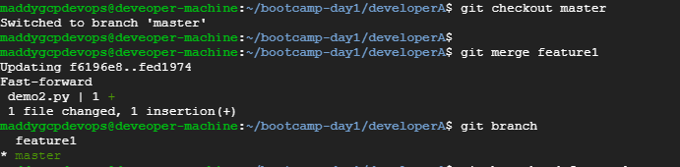

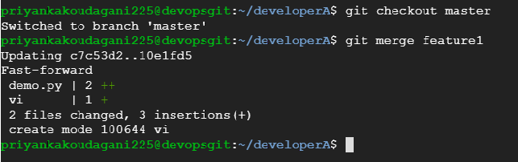

17)After merging the code, I have used the git branch -d feature1 to delete the branch.

